High Res Stepper motor with Mini V2 Controller Quick Guide
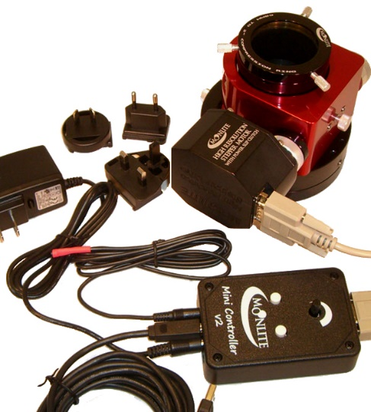
Test general operation
- Plug controller and motor in. Connect power and press the white buttons on mini V2 controller to jog focuser in/ out.
- Note Red LED will blink during movement, black knob controls speed of motor.
- Loosen the slip clutch and rack drawtube up down with manual knob. Motor will just slip in this mode if you use the controller. Tighten the clutch back up for motor operation.
- Install Software and USB driver to test basic PC connectivity. See Download Tab for software and instructions.

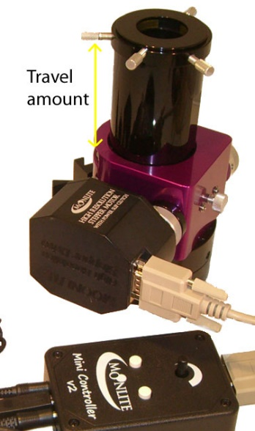
Calculate number of steps possible
- Calculate the number of steps your particular focuser has based on the drawtube travel installed. Note: Step size is = .00016”
- Example a CS model SCT focuser with the .95” travel drawtube installed would have about 5937 steps total.
- A CF model refactor focuser with the 4.5” long travel drawtube installed would have 28,125 steps total.
- You can now estimate how far you will be able to move the focuser before running in to the mechanical stops. Note: no damage will happen when running in to the stops, it will simply slip on the slip clutch or shaft drive before harming anything. However, running in to the stops after the focuser is calibrated will cause the step count to be off and will require re-setting the zero home positions.
Setting Zero Focus home position
- Rack drawtube the whole way in, either manually with the knobs, or holding down the “In” button on the controller.
- Start the Moonlite Non-ASCOM utility program and connect to the controller.
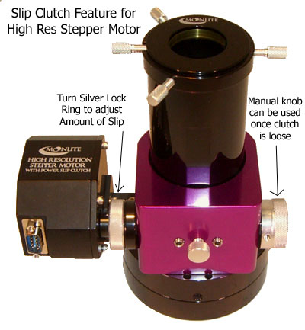
- With the focuser racked the whole way in- press “Null” to make it the zero home position. Zero step count is now set at the racked in position.
- Test the movement of the focuser, pick a positive number to goto and observe the focuser moving to that step count number. Practice moving the focuser around to get familiar with the application. Note: only positive step counts are supported with Astro focusing software.
- Note- hold Clutch ring with left hand and regular knob with right hand.
Turn like a lid on a jar to either tighten the clutch or loosen the clutch.
If the manual knob turns easily, then the clutch is not tight.

Install the ASCOM driver and set up the focuser for automation using your imaging software. Please note only 1 application at a time can connect to the Mini V2 controller, so please disconnect the Moonlite application before connecting your ASCOM program or SKYX plug in.

Moonlite NON-ASCOM Utility program version 1.4
See Download Tab for installation

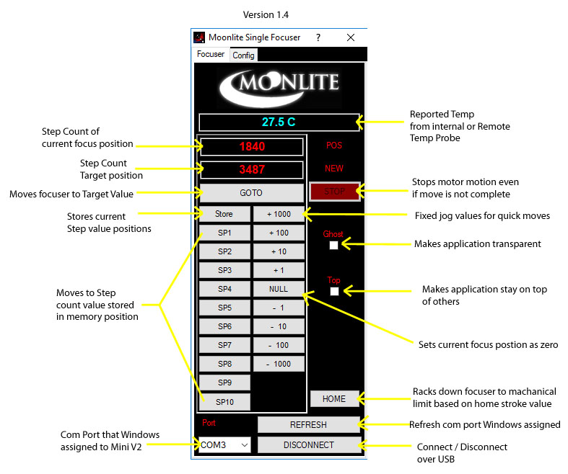
This application is provided for basic operation/ testing of the focuser with no ASCOM required. However, most customers will be running ASCOM. Please make sure you have ASCOM 6.2 platform installed and our ASCOM Driver. The mini V2 controller will work fine under all ASCOM based programs.
The SP1-8 buttons can be used to store step count positions. Move the focuser to the current desired position and press the store button and then one of the SP buttons. The step count value will be stored temporarily in to the button until the application is closed. To save SP memory positions, use the store and save button in the configuration tab. You can also rename the buttons if you open the stored file with note pad and rename the buttons/ or even the step count. However, you will need to load the file each time you start the application.
The Home button allows the focuser to be remotely Homed or “Zeroed”. When clicked, the focuser will rack down past the value set in the config tab’s “Home Stroke” box. The number of steps entered in to the Home stroke box should be greater the total steps the focuser can move. Example for a .95” travel drawtube provides 5937 steps, enter a value of 6200 in the Home Stroke box. That will insure the focuser will rack down to the stop and be completely zeroed out. Remember the focuser will simply slip when hitting the stop causing no damage.

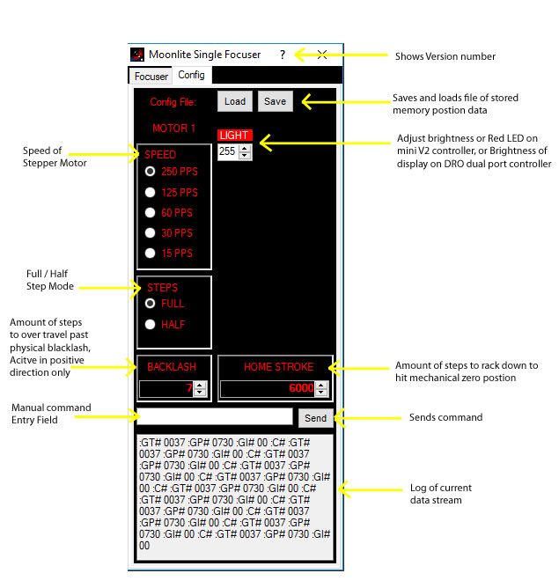
Configuration Tab
Backlash value will allow the focuser to over shoot positive moves by the value set in the box, then come back to the target move, this will take any backlash out that may be present, as the move is always pulling the load up in the same direction every move. Just enter a value greater then the backlash amount observed. Normally a value of 5 to 10 is plenty larger then the actual backlash of the motor.
It is possible to send basic raw commands to the controller using the field box and the send button. Please see high res stepper motor document for a full list of commands. This is provided for more advanced users.
Moonlite Telescope www.focuser.com

